**TRAVELL PLANNER**

**TASK 1**

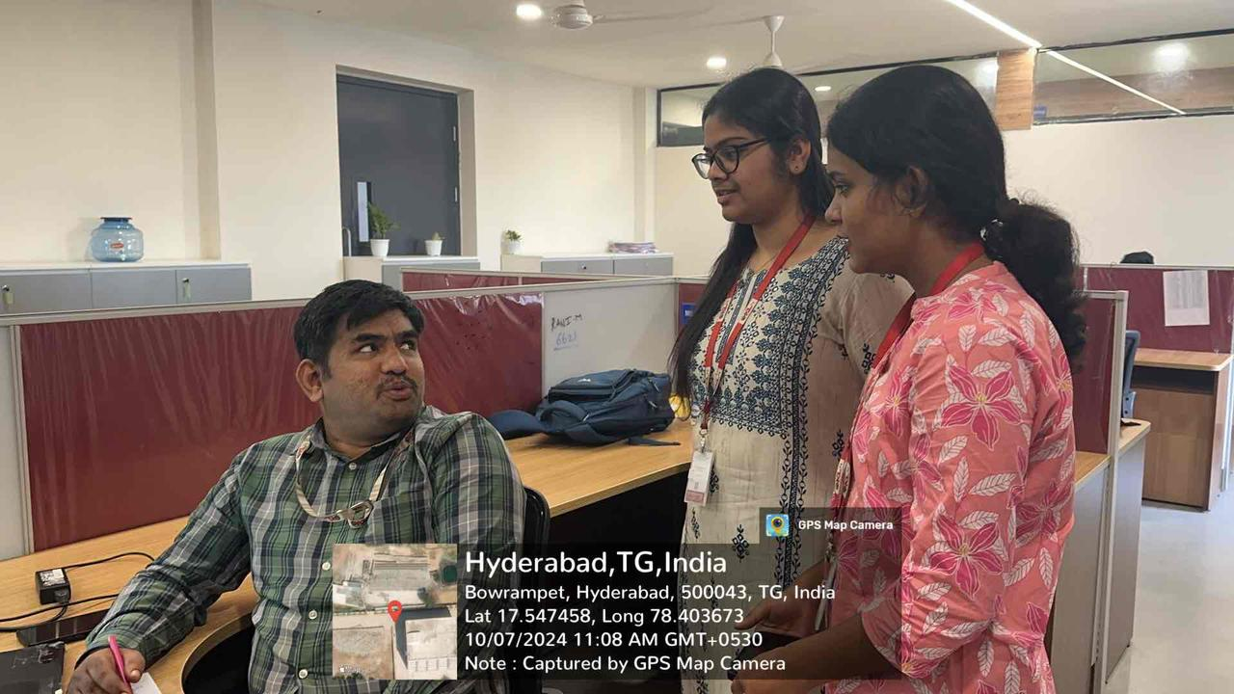

**Interview questions**

**1)**Can you describe the main vision you have for the travel planner project?  
**Client:** We envision an AI-powered platform that provides personalized travel recommendations, helping users plan trips effortlessly. We want the AI to assist in everything—flights, accommodations, itineraries, activities—based on the user's preferences, budget, and previous travel history.

**2)**What specific problems are you hoping to solve with this AI/ML travel planner?  
**Client:** Travel planning is time-consuming and overwhelming for most users. We want to simplify the process by offering relevant suggestions quickly. Our goal is to provide a solution that reduces decision fatigue, adapts to real-time changes, and offers users a unique, tailored experience that feels personal rather than generic.

**3)**What kind of data do you currently have that we can use to train the AI models?  
**Client:** We have user profiles, historical travel bookings, browsing patterns, and feedback from previous travelers. We also have access to third-party datasets on flights, hotels, and activities. Additionally, we’re looking to integrate live data feeds from APIs—such as real-time pricing for flights and hotel availability.

**4)**Great! Do you have preferences for the kinds of inputs the users will provide?  
**Client:** Yes, we want users to enter their destination, travel dates, budget, and preferred activities. We’re also exploring the idea of conversational inputs, where users can describe their ideal trip in a natural language format, like "I want a beach vacation in December for under $2000."

**5)**How personalized should the travel recommendations be? Are you looking for deep customization, or would basic filtering suffice?  
**Client:** Deep customization is key. We want the AI to learn from user behavior—like what destinations or types of activities they prefer, how they’ve traveled in the past—and use that to offer more accurate recommendations. For example, someone who enjoys adventure travel shouldn’t get suggestions for luxury spa resorts unless they specifically ask for it.

**6)**How do you imagine users interacting with the platform? Would it be through a chatbot, a mobile app, or a web interface?  
**Client:** We’d like to offer multiple ways for users to interact. A mobile app is essential since most people plan travel on their phones. A chatbot feature could also be useful for real-time interaction and conversation-based travel planning. Users should be able to type or talk to the AI, and it should respond with suggestions or answers.

**7)**What kind of response time or interaction flow are you expecting from the AI?  
**Client:** It should be quick and responsive, providing recommendations in real-time or with minimal delay. If users adjust preferences mid-search, the AI should instantly adapt and show updated suggestions.

**8)**Since this involves user data, how do you want to approach privacy and security?  
**Client:** Privacy is a major concern for us. Users will be sharing personal preferences, travel history, and possibly even payment information, so we need strict data encryption and compliance with privacy regulations like GDPR. We want transparency, so users know exactly how their data is being used.

**9)** Do you have any plans for expanding the platform after the initial launch?  
**Client:** Absolutely. We want to expand into group travel planning, add social sharing features, and eventually partner with airlines, hotels, and tour operators for exclusive deals. We’re also thinking about integratingvirtual reality tours so users can preview destinations before booking.

**10)**Is there anything else you'd like to add or emphasize for the project?  
**Client:** Just that we’re really focused on creating a user-friendly experience that simplifies travel planning while offering highly personalized suggestions. We’re counting on the AI to provide real value, and we’re excited to see how it evolves over time!

**TASK 2**

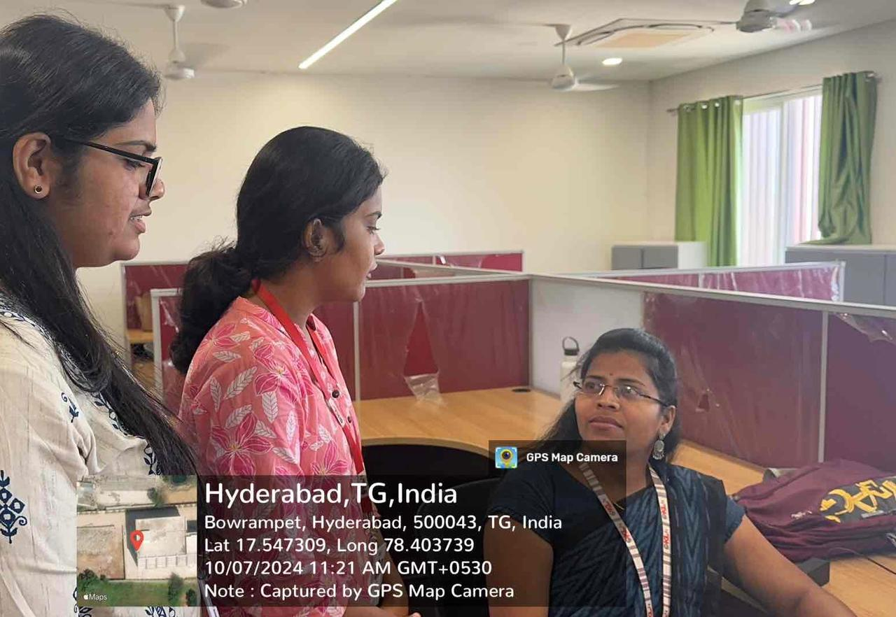

1. What unique challenges do you think travelers face today that the Traveler Planner system can address?

**Client**: Travelers face challenges like last-minute schedule changes, complicated logistics for multi-destination trips, and real-time communication with various service providers. The system could streamline all these aspects by integrating multiple sources of information, allowing users to receive instant updates on their entire journey, and even enabling predictive analysis of potential travel disruptions.

1. How can the Traveler Planner system cater to different types of travelers, such as solo adventurers, families, or business travelers?

**Client**: The system could offer customizable user profiles where solo travelers, families, and business travelers receive tailored recommendations. For solo travelers, the focus could be on local experiences and safety tips; for families, it could provide family-friendly accommodation and activities; for business travelers, it could offer tools for managing meeting schedules and logistics.

1. What role do you see user-generated content, like reviews or personal travel experiences, playing in the system?

**Client**: User-generated content can create a trusted, community-driven system, where travelers can view itineraries, read reviews, and access firsthand advice. By showcasing popular user itineraries or curating trending experiences, the platform could drive engagement and give travelers more personalized insights.

1. How would you like the Traveler Planner system to handle unforeseen changes, such as flight cancellations or natural disasters?

**Client**: The system could feature a robust alert mechanism, instantly notifying travelers of changes and offering immediate solutions, such as automatic rebooking options or even alternative destinations. It could also integrate travel insurance options, advising users on claims processes during emergencies.

1. What types of partnerships or integrations (e.g., airlines, hotel booking platforms, ride-sharing services) would you consider essential for the system?

**Client**: Crucial partnerships would include airlines, hotel chains, rental car companies, and ride-sharing services. Additionally, integrations with local tour guides, event organizers, and insurance providers would enhance the user experience by offering complete, real-time travel assistance from start to finish.

1. How important is sustainability in travel planning, and would you want the system to suggest eco-friendly options for transportation, accommodation, or activities?

**Client**: Sustainability is essential, and the system should offer a "Green Travel" option. This could include carbon-offset suggestions, green hotels, and eco-tours, with the option for users to filter for sustainable travel choices. The platform could also display environmental impact scores for each trip to promote awareness.

1. How do you envision the system providing value for frequent travelers who might be planning multiple trips simultaneously?

**Client**: A multi-trip dashboard could allow frequent travelers to seamlessly switch between different itineraries, manage ongoing plans, and track deadlines (e.g., visa or flight booking reminders). Priority alerts for essential documents or booking deadlines would be especially useful.

1. Would you like the Traveler Planner system to support language translation or local cultural insights for international trips?

**Client**: Yes, an integrated translation tool and local cultural insights would greatly enhance the experience. Features like real-time language translation, key local phrases, and etiquette tips would enable users to navigate foreign environments with confidence.

1. How would the system address budget constraints for travelers, especially when planning cost-efficient trips?

**Client**: The system could offer a budget optimization tool that tracks all expenses in real-time and provides cost-cutting suggestions. It could also allow users to set a maximum budget for trips and receive alerts on flight or accommodation price drops, along with cost comparison for transport options.

1. How do you see the Traveler Planner handling complex travel plans that involve multiple destinations, modes of transportation, or visa requirements?

**Client**: The system could include a complex itinerary builder with options for multi-leg trips. Users would be able to integrate different transport modes and check visa requirements for each stop. It could provide automatic reminders for document uploads, travel vaccinations, or any restrictions for different destinations.

**TASK 3**

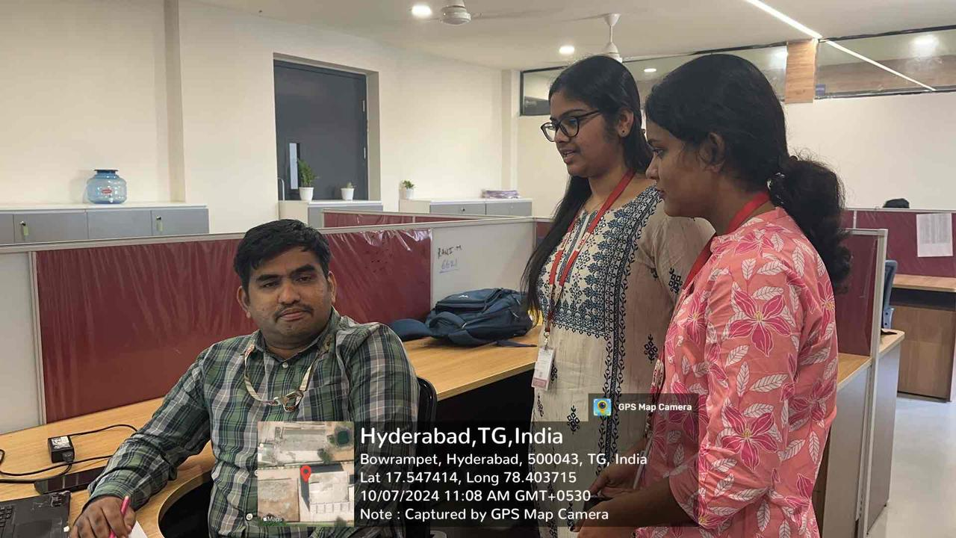

1. What is the primary goal you want the Travel Planner system to achieve?

**Client**: I want the system to simplify trip planning by centralizing everything from flights to accommodations and activities. It should also provide seamless coordination, even with last-minute changes.

1. Who is the target audience for the Travel Planner system?

**Client**: The target audience is diverse, including solo travelers, families, business travelers, and adventure seekers. We want the system to be flexible enough to cater to various needs.

1. How important is user personalization in the system?

**Client**: Personalization is key. The system should be able to adapt to individual preferences, like favorite types of activities or budget limitations.

1. What kind of user interface do you envision for the Travel Planner?

**Client**: It should be intuitive and easy to navigate, with minimal clicks to book or manage trips. A mobile-friendly interface is essential since many travelers plan on the go.

1. How would you like the system to handle travel disruptions, such as cancellations or delays?

**Client**: The system should immediately notify users of disruptions and provide alternative options, like rebooking or suggesting different routes. Real-time alerts are crucial.

1. What is your budget expectation for users when they plan trips through the system?

**Client**: Users should be able to set their own budget limits, and the system should offer recommendations that fit within those constraints. It should also notify them of price drops or promotions.

1. Do you want the system to offer real-time collaboration, where users can share their itinerary with others?

**Client**: Yes, especially for group trips or business travelers. It would be great if users can collaborate on trip details or share plans with friends and family.

1. How important is sustainability to you in travel planning?

**Client**: Very important. The system should highlight eco-friendly options, like low-carbon flights or green-certified accommodations, and help users make more sustainable travel choices.

1. Would you like the system to integrate with local services, such as ride-sharing or tour guides?

**Client**: Absolutely. Integrations with ride-sharing apps, local guides, and activities would provide a seamless experience from booking to the actual travel.

1. What kind of content do you think will keep users engaged with the platform post-booking?

**Client**: Travel tips, personalized suggestions, and even user-generated content like reviews or shared itineraries. These could keep users coming back to the platform even after booking their trip.

**TASK 4**



1. Do you want AI-driven recommendations based on user behavior, such as preferred destinations or types of experiences?

**Client**: Yes, personalized AI-driven recommendations would enhance the user experience by offering tailored options based on past behavior and preferences.

1. How important is it for the system to support multiple languages, especially for international travelers?

**Client**: Very important. The system should support several languages and offer real-time translation for users traveling to non-English speaking countries.

1. Should the system handle trip documentation, such as boarding passes or visa requirements?

**Client**: Yes, it would be helpful if the system can store and manage trip documents, send reminders for visa applications, and provide updates on travel restrictions.

1. How do you see the system addressing the needs of budget-conscious travelers?

**Client**: It should provide price comparison tools, budget tracking, and notifications for fare drops. Offering last-minute deals would also be appealing to budget-conscious travelers.

1. Would you want the system to offer health and safety-related information for destinations?

**Client**: Yes, it should provide essential health and safety info, including travel advisories, vaccination requirements, and local emergency contacts.

1. How important is offline access to the system for travelers who may not always have internet access?

**Client**: Offline access is critical, especially for itinerary details and travel documents. Users should be able to access vital information even without a stable internet connection.

1. Should the system allow users to book everything in one place (flights, hotels, activities), or should it focus on certain aspects?

**Client**: Ideally, everything should be bookable in one place for convenience. This would streamline the experience and make it easier to manage all aspects of a trip.

1. Would you like the system to offer a social aspect, where users can connect with other travelers or share experiences?

**Client**: Yes, a community aspect where users can share itineraries, reviews, or even collaborate on trips would be valuable.

1. How important is customer support, and would you like AI-driven chatbots or live agents?

**Client**: Both AI-driven chatbots for quick questions and live agents for more complex issues would be ideal. Travelers should feel supported 24/7.

1. How do you envision monetizing the system (e.g., through partnerships, premium subscriptions, or advertising)?

**Client**: Partnerships with airlines, hotels, and local activity providers could be a significant revenue stream. A freemium model with premium features for personalized itineraries or advanced booking options could also work.

**TEAM MEMBERS**

SREEJA NASANI-2320030342

THOTA HEMA-232003007

SRIJA-2320030093

JAHNAVI PATNALAA-2320030358

* SREEJA NASANIe system could include a **budget management tool** that tracks all trip-related expenses in real time, such as flights, hotels, and activities. Additionally, it could offer **price comparison features** and **notifications for discounts** or **fare drops** to help users plan cost-efficient trips.

1. How do you see the Traveller Planner handling complex travel plans that involve multiple destinations, modes of transportation, or visa requirements?

* The system could provide a **multi-leg itinerary planner** that simplifies complex trips, including different transportation modes like flights, trains, and buses. It could also help users **track visa requirements**, offering reminders for application deadlines, document uploads, and any destination-specific travel rules.